This is a logbook entry to complete and email to your faculty supervisor as progress update on a biweekly basis (i.e. once every 2 weeks). Your submissions will be used as reference for your internship progress and will be assessed towards the overall performance of your internship journal.

Important Note:
- As consistency of submissions is assessed as part of your internship, all submissions should be made on time. Any delays should be informed and prior approval to be sought with your faculty supervisor. Late entries without prior approval will be considered invalid for assessment.
- Before submission, please obtain clearance for your logbook content from your organisation supervisor to ensure that no confidential information is included.

Student Name | : | Tan Yi Rong
Student ID | : | U2320967K
Company Name | : | GlobalFoundries
Company Supervisor | : | Ng, Christopher
Logbook Entry Period | : | 25/08/2025 to 05/09/2025
Date of Submission | : | 09/09/2025

- State the Internship Objective, Scope, and Problem Statement
(Briefly describe the objective(s) provided by the internship organisation, and the expected scope of work and deliverables expected from you to address the issues.)
Objective:
The main objective of this internship is to design and implement an automated sensor system to monitor the wear and tear of Overhead Hoist Transport (OHT) wheels in the Automated Material Handling System (AMHS) used in semiconductor manufacturing. This system aims to support predictive maintenance and reduce production downtime by enabling timely part replacement.

Scope of Work:
- Develop a laser sensor-based solution to measure the height of OHT wheels, allowing for accurate detection of wear over time.
- Automate the collection and processing of maintenance data to support predictive maintenance planning.
- Understand the operational context of the semiconductor industry to ensure the solution aligns with production requirements.
- Assist in improving data accuracy and integration where necessary to support maintenance workflows.

Problem Statement:
The current OHT maintenance process lacks a reliable method to detect wheel wear in real time, leading to reactive maintenance and potential production disruptions. This project focuses on developing a sensor-based system to monitor wheel height and wear, enabling predictive maintenance and minimizing unexpected downtime.

- Describe your work done over the past 2 weeks
Work and/or Tasks Performed | Date (From) | Date (To)
Replicating and adjustments of OHT track for the different Fab’s maintenance room on SketchUp | 25/08/25 | 28/08/25
Special Networking Lunch with Dr Dobromir Gaydazhiev, spoke about how embracing cultural differences and discomfort builds a growth mindset | 27/08/25 | 27/08/25
Designing of 2 sensor frames that will be able to cater to 3 Fabs | 29/08/25 | 02/08/25
Meeting discussion for additional criteria on the current sensor frame that will be implemented across 3 Fabs. Reviewing the progression for the project Gantt Chart | 02/09/25 | 02/09/25
Re-designing the sensor frames to configure the restrictions and additional implementations | 02/09/25 | 04/09/25
Created a proposal to Supervisors on the sensor frame for the approval for manufacture. | 05/09/25 | 05/09/25

Describe and reflect on your work/task outcome/learning over the last 2 weeks

(Illustrate the challenges that you are facing; describe areas that you have done well and areas that could be better managed)

Over the past two weeks, my main effort has been on the sensor frame design. I started by using SketchUp to create a model of the OHT track and its adjustments in the different maintenance rooms. This was a necessary step to make sure the final design would fit correctly.
After that, I focused on designing two sensor frames that could work in three different Fabs. A meeting was held to discuss more needs for the frame and to review the project's Gantt chart. We looked at what was next, what tasks were delayed, and made adjustments to the project timeline. Due to these delays, some sub-tasks have to be done concurrently to stay on schedule. Based on this feedback, I had to re-design the frames to meet the new requirements and fix some problems. The work ended with a proposal I created and submitted to my supervisors. The proposal is currently pending for approval and is subject to further feedback and re-designing if needed. The proposal includes adjustments to the OHT tracks, such as moving or adjusting the overhead cable tray. This is necessary due to the sensor's specifications and the spatial constraints of the track, which limit where the frame can be placed. The frame was also designed with additional mounting holes for future needs, such as adding more sensors later on.
I also attended a networking lunch with Dr. Dobromir Gaydazhiev, where he spoke about "Growth Mindset in a Global Context." The talk explored how cultural differences are not barriers but opportunities for learning. It reminded us that meaningful growth often comes from embracing discomfort and challenges.
The main challenge was redesigning the sensor frames to meet several new requirements at once. The most difficult part was ensuring the frame was strong enough to withstand vibrations while also adhering to a strict height restriction and keeping the sensor's output within a 210mm range of the track. Minimizing these vibrations is key to getting accurate data on the OHT wheel dimensions. In addition, the spatial constraints of the track required me to propose adjustments to existing infrastructure, like the overhead cable tray, to fit the new frame.
The project's Gantt chart review also highlighted the need to run some tasks at the same time. This experience taught me the importance of clear communication early in a project and how to manage timelines more effectively, especially when faced with delays.

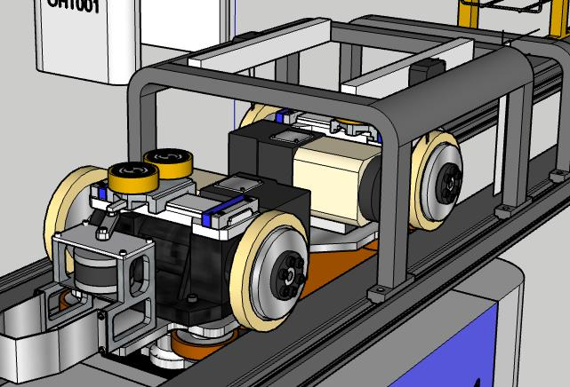
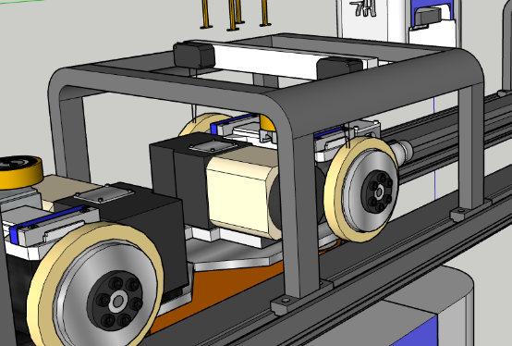

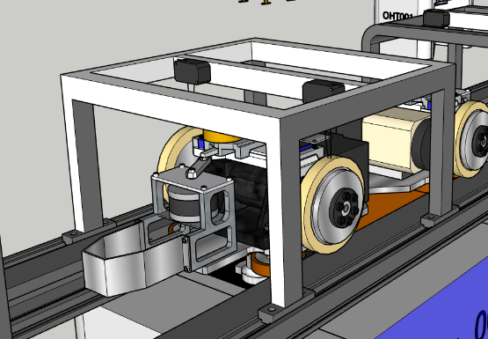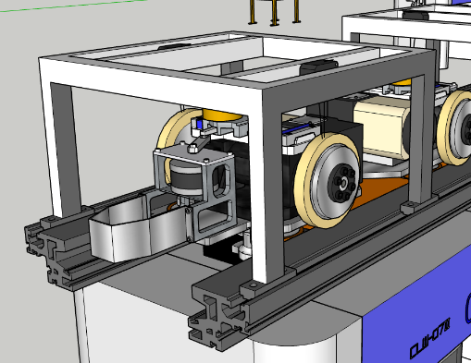
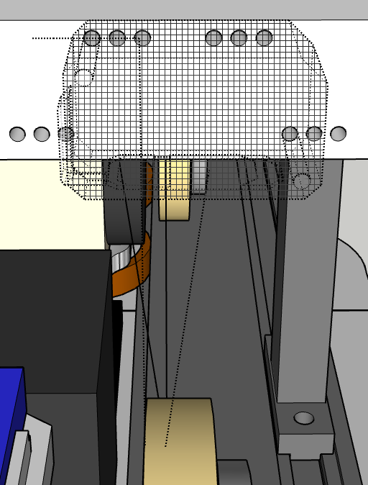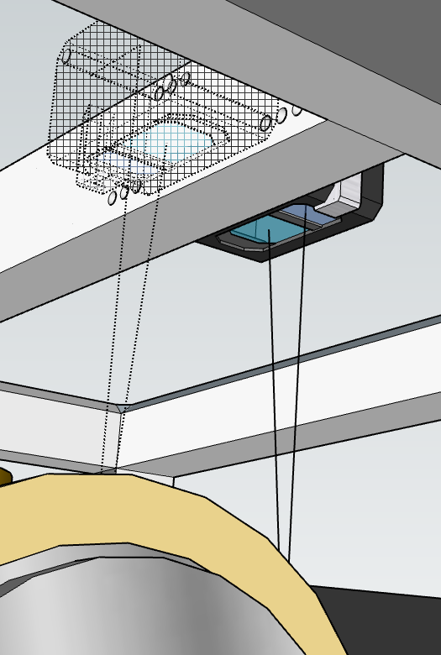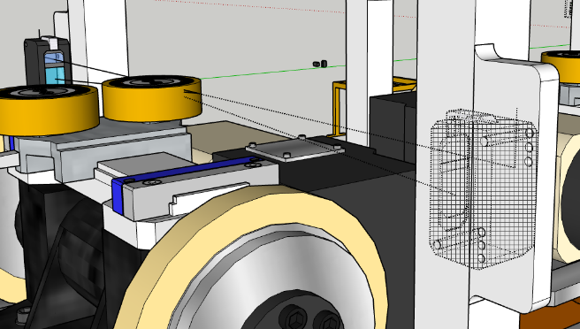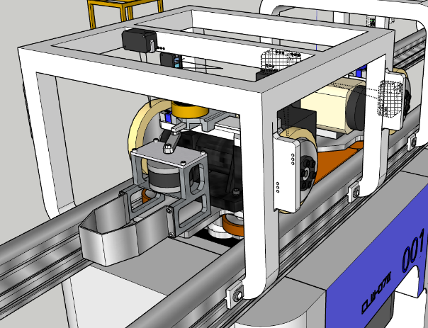

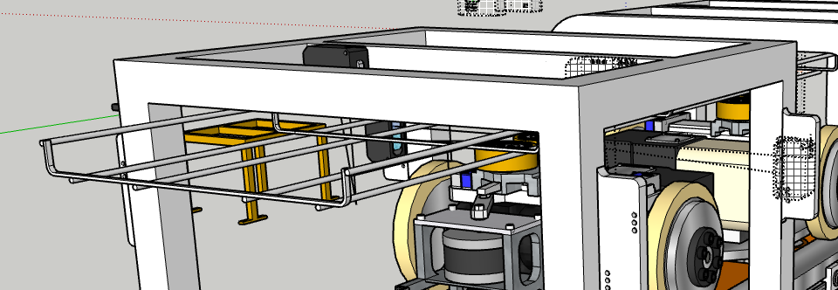
Fab 7H (Cable Tray Restrictions – moving of cable)

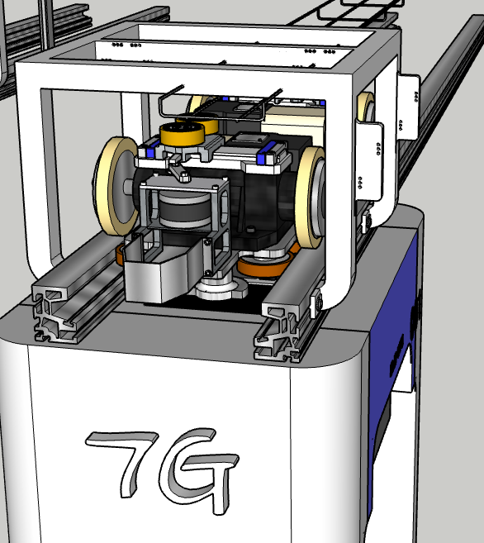
Fab 7G (Cable Tray Restrictions – removing tray)
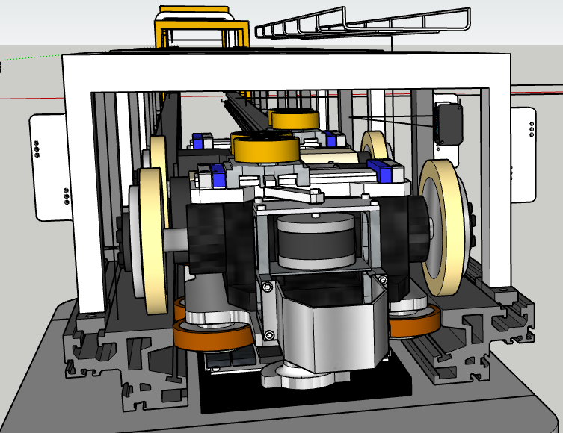
Fab 7 (No Cable Tray Restrictions)

